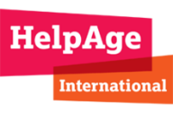
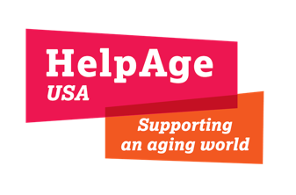
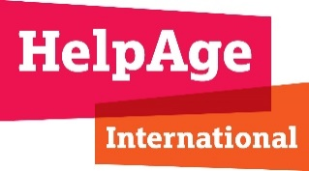
HelpAge Situational Report: Pakistan Floods
September 6, 2022

Overview
- An estimated 33 million people need humanitarian assistance.
- One million homes are fully or partially damaged.
- 110 districts are affected across the country and 66 are declared calamity-hit.
- 1,061 people are estimated to have died, 1575 are injured, and 720,000 animals have perished.
- HelpAge will conduct a Rapid Needs Assessment in the Sindh province this week.

Response Plan

Immediate Relief (1-3 months)
- Shelter and Non-Food Items (NFIs) - Shelter kit and toolkit for removing debris, tarpaulin or temporary shelter for livestock, kitchen utensils, mosquito nets, and repellents
- WASH - Safe drinking water and water storage kits, hygiene kits and dignity kits for older people, girls, and women
- Food Security and Livelihood - Multi-purpose cash assistance, dry rations to most vulnerable families headed by older people and persons with disabilities, vaccination of livestock
- Health - Inclusive Primary Health Care (PHC) services, psychosocial counseling to affected older women and men, and assistive devices for older people and those with disabilities

Medium to Long Term Recovery (4-12 months)
- Shelter and NFIs - Reconstruction/repair of damaged homes, conditional cash grants, animal shed construction
- WASH - Rehabilitation of water sources, material for latrines construction
- Food Security and Livelihood - Cash grants to restore livelihoods, cash for purchasing livestock, enterprise development and training, distribution of seasonal agricultural seeds
- Health - Rehabilitation of government health facilities

Current HelpAge Activities
- HelpAge and its local partner, Community Development Foundation, are responding in Jhal Magsi, one of the most affected districts in the Balochistan province, providing 400 NFI kits, 100 assistive devices, and multi-purpose cash to 200 older people and persons with disabilities.
- We are also responding in the district of Khairpur in the Sindh province, in collaboration with our local partner, HANDS, to assist the government in dewatering buildings, and distributing shelter and NFI kits to 250 beneficiaries.
- HelpAge is targeting 7,600 beneficiaries (950 households.)
Coordination with Other Stakeholders
- HelpAge is working closely with the district authorities and Provincial Disaster Management Authority (PDMA) to avoid duplication of efforts and ensure safety and security for the staff and beneficiaries.
- We are participating in the Health, WASH, Food Security and Livelihood, and Protection working group, and actively engage in the UN Clusters (if/when activated).
- HelpAge is supporting a provincial network of organizations working for older people called Burzog Dost Network.

