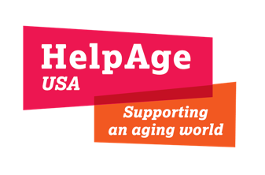

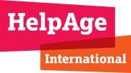

Pakistan Floods: Rapid Needs Assessment of Older People

October 24, 2022

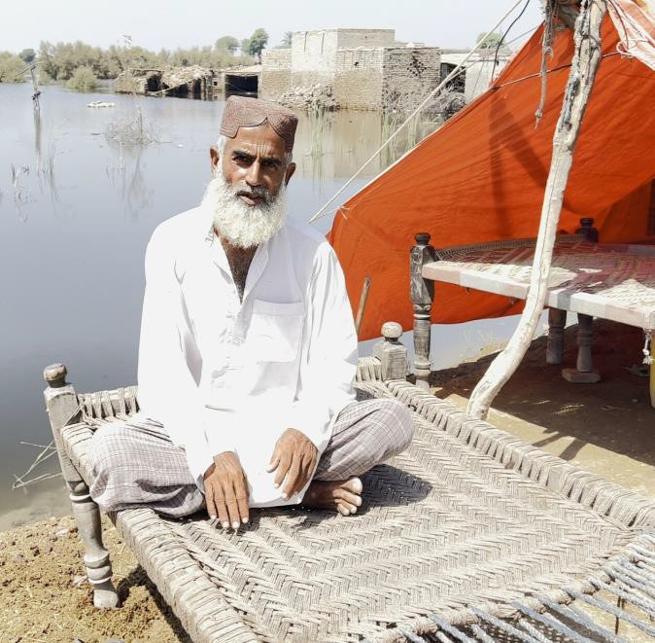
Context
Between June and August 2022, Pakistan experienced a devastating monsoon season where rainfall was close to three times more intense than the 30-year average. The rains resulted in uncontrollable flash floods and landslides across the country, including in urban areas.
According to the ACAPS August 2022 briefing note, Around 33 million people were, including at least 7.9 million people who have been displaced, of whom some 598,000 are living in relief camps.
Over 99% of the affected population are in the provinces of Balochistan, Khyber Pakhtunkhwa, Punjab, and Sindh. In most regions the water levels are gradually receding but in others, especially in Sindh, they remain and are becoming stagnant.
This disaster has significantly impacted older people. As of 2019, almost 15 million people, or
7% of the population are over 60. Based on these figures, an estimated 2 million older people have
Muhammad Zaman, 61, Sindh province

been impacted by the floods.
To understand the impact of the floods on older people, HelpAge International carried out a Rapid Needs Assessment (RNA) from September 21 to 26, 2022. This RNA is based on interviews with 1,336 older people (50+) in Sindh province (Jacobabad, Khairpur, Shikarpur and Dadu); Balochistan province (Jhal Magsi); and Khyber Pakhtunkhwa province (Nowshera).

Key Findings
Shelter
- 69% of older people interviewed reported that they do not have shelter. This varied between locations, with those interviewed in Sindh significantly less likely to have shelter (85%) compared to those interviewed in Balochistan (39%) and Khyber Pakhtunkhwa (8%). This is unsurprising given that Sindh is the worst affected region. Over 2 million homes were affected by the floods in Pakistan, of which 88% were in Sindh. In Sindh province, 7.2 million are displaced and more than 570,000 people are living in relief camps.
- While the water has receded in some areas, enabling people to return to damaged or destroyed dwellings, in others - especially Sindh - the floodwaters have yet to recede, and many older people find themselves camped on higher ground, including on roadsides and embankments near their flooded homes. Of those older people interviewed 19% were living in temporary shelters on the roadside where the conditions are often dire. For example, some are sleeping on just a bed with merely a piece of fabric to provide shelter.

@HelpAgeUSA HelpAge USA

Others interviewed were either in designated (13%) or spontaneous (10%) camps. According to a recent government needs assessment, 98% of camps are in the Sindh province. These camps are often managed by government and other humanitarian organizations. The camps have been established in school and college buildings and are often not suitable for older people due to limited space and access. These living arrangements are likely to worsen the underlying health conditions of older people and affect their wellbeing. They also provide older people with little privacy and expose them to a range of protection and safety risks. The use of schools as emergency shelters has also reduced the number of children able to attend school.
- Of those who have shelter, 31% of people reported that it is inadequate, including because their living place had been significantly damaged. Many of the homes of those interviewed are made out of mud mixed with stones (Kacha houses) and/or materials such as bamboo, straw and straw-sheets which makes them more susceptible to damage from the heavy rains.
- Half of the respondents (50%) stated that the key challenge they faced was not being able to afford building materials to repair or rebuild shelter, which is crucial in advance of winter. There is an urgent need to provide cash for building materials. The current inflated prices of building materials should be costed when providing cash assistance.
Older people should be consulted in the design of cash and shelter interventions, so that they are fit for purpose. For example, older people who secure building materials may require additional physical support to help with construction. Any new homes should also consider the requirements of those with physical disabilities or visual impairments. This could include single-story homes, entrances without steps, and sufficient natural light.
- Some older people reported that their shelters are far away from friends and family. While displacement for many will be short term, others may choose to migrate or will be displaced for longer periods. This could leave some older people isolated and without vital support networks.

Top 6 priorities (high or very high)
90%
80%
70%
60%
50%
40%
30%
20%
10%
0%
82%
64%
62%
52%
51%
49%
Cash Food Shelter Household items Medicines Hygiene items

WASH Facilities
- Almost half (46%) of older people interviewed reported that they do not have access to clean drinking water, with the majority in Sindh (59%) reporting access problems, and fewer in Balochistan (25%) and Khyber Pakhtunkhwa (4%). In Sindh and Khyber Pakhtunkhwa many older people are mostly using ground water, while in Balochistan older people are using wells and streams. Pipeline water facilities were not working in any of the areas assessed. According to OCHA, the floods have resulted in an additional 5.4 million people across the country having to rely on unsafe sources of drinking water.
- The destruction of water supply systems has meant that many of the water points that older people previously used such as hand-pumps, bore holes, and tube-wells no longer function. A quarter (25%) of older people interviewed reported having to travel a long way to access water. For those with physical disabilities and lacking support, this presents a significant concern. Until the government can rehabilitate the water supply systems, door-to-door delivery methods should be considered.
- In addition, some older people are reporting that the water available from the water points has a bad smell and/or a bad taste. Drinking dirty water exposes people to an increased risk of water-borne diseases such as cholera and typhoid. Some older people are more at risk from these diseases due to existing health conditions and weaker immune systems. In addition, unclean water increases the likelihood of livestock getting ill, which is a major source of income for many in Pakistan. A lack of accessible water also reduces farmers’ ability to irrigate their land.
- Older people also reported struggling to access both toilet facilities (63%) and bathing facilities (62%). This was again worse for those interviewed in Sindh as compared to those in Balochistan and Khyber Pakhtunkhwa. The floods have significantly damaged sanitation facilities in affected communities. OCHA estimates that around 6.3 million people have been deprived of toilet facilities. This in turn has led to an increase in open defecation from 21% of the population to 35%. In some cases, latrines have been filled with mud, which has resulted in contaminated water overflowing. All these present serious hygiene risks and increase the likelihood of water-borne diseases and diarrheal outbreaks. A major issue reported by around half of older people interviewed was the lack of privacy of sanitation facilities. This is because there are often no doors/broken doors in latrines and no lighting systems in camps and temporary accommodation.

Have access to clean drinking water
46%
53%
Yes
No
Have access to toilet facilities
33%
63%
Yes
No

Food
- 60% of older people interviewed reported that they did not have sufficient food. This is worse for those in Sindh (78%), especially in the districts of Dadu and Shikarpur, compared to those interviewed in Balochistan (26%) and Khyber Pakhtunkhwa (9%). OCHA estimates that 14.6 million people need food assistance. This is due to the large-scale destruction of agricultural land and the subsequent loss of income for many farmers. It is estimated that 5.3 million acres of crops have been affected 4.8 million are in Sindh.
- According to a recent government assessment in Sindh, Punjab and Khyber Pakhtunkhwa, three quarters of respondents reported that people were unable to work due to the floods. This will seriously affect their ability to earn an income and meet food consumption and other essential needs. This assessment also highlighted that damage and loss of livelihood assets due to floods has affected income generating activities. This includes 60% reporting they had lost transport related livelihood assets (e.g., motor bike, rickshaw, bicycle, carts); 60% reporting lost agriculture assets; and 31% reporting that their shops/business (e.g., shops, stalls) were damaged.
- Another key source of livelihoods for people in Pakistan is livestock, and many have been killed in the floods. Livestock often also serves as collateral for loans, including to finance the purchase of seeds for sowing crops. A WFP and FOA assessment in Balochistan found 95% of goats had died, as well as 77% of sheep, 51% of cattle and 32% of donkeys in the villages where the organizations conducted interviews.
- The most significant barrier to accessing sufficient food, reported by 43% older people, was that they could not afford it. Many of those in the flood- affected communities have also faced rising inflation and significant price increases for basic commodities, such as rice, wheat, pulses, and eggs. For example, in the past two months, the price of wheat flour has increased by up to 20% in markets serving flood affected areas.
- Many organizations are providing food kits with rice components which are not always suitable for older people with medical conditions such as hypertension and diabetes. The specific dietary requirements of older people should be considered when providing food assistance.
- Older people interviewed also reported insufficient availability food, linked to supply chain disruptions: 25% reported that there is not enough food in the market, and 16% of the available food is inappropriate.

Going to bed hungry
50%
40%
30%
20%
10%
0%
39%
39%
14%
8%
Never
1-2 nights per week
3-5 nights per week
Every night

Cash Assistance & Income
- Almost three quarters (74%) of older people reported that they would be able to utilize cash assistance if it was provided. For those interviewed in Balochistan and Khyber Pakhtunkhwa provinces, 99% responded that they would be able to use it, while in Sindh there were more variations between districts with 94% in Dadu, 71% in Jacobabad, 55% in Khairpur and 26% in Shikarpur. The reason for these variations needs to be explored further.
- There is also a gendered component to utilization of cash assistance. Overall, 84% of older men responded that they could use cash assistance, while only 65% of women responded that they could. This could be that in specific cases older men prefer that they purchase items from markets and that older women are unaccustomed to accessing these markets independently. It should also be mentioned that market functionality in Khaipur and Shikarpur was lower at the time of the assessment.
- For those who could utilize cash, 55% said they preferred Pakistan’s Computerized National Identity Card (CNIC) to access it, followed by cash in hand (17%), bank cheque (15%) and through mobile cash accounts (13%). Again, there were significant variations between locations, with some locations preferring cash in hand or bank cheques over CNIC. This highlights that older people should be consulted during the design phase of cash interventions, and if possible, a mixed approach used. It is important to also note that only 19% said they would need transport support to access cash assistance through a bank cheque or CNIC transfer. Older people said their priorities for purchases with cash include: shelter repair/construction (48%), purchasing food for the family (17%) and health needs (12%). The majority of older people in Pakistan do not receive a state pension.
- The destruction caused by floods has devasted the local economy. Older people in Balochistan, Khyber Pakhtunkhwa, and Sindh provinces play a vital economic role, running small businesses, rearing livestock, farming, and working in fisheries. However only 24% said that they have an income. This again varies between districts with those in Dadu the least likely to have an income. It is therefore important that older people are included when implementing livelihoods programs. Economic impacts have compelled 57% of older people interviewed to borrow money, mainly from family members. This was higher for those who are displaced (61%) than for those who are not (32%).

Use cash assistance if provided

25%
Yes No
75%
Borrowed money
41%
57%
Yes
No

- Preliminary estimates by the World Bank suggest that as a direct consequence of the floods, the national poverty rate could potentially increase by 4.5% to 7%, pushing between 9.9 million and 15.4 million people into poverty. A poverty indicator indicated by this research is that 22% of older people reported they are being forced to skip meals, going hungry between 3 and 7 nights a week.

Health
- Almost nine out of ten (87%) of older people reported having a health condition, with 42% having more than one. The top six health conditions were joint aches and pains (31%), hypertension (23%), respiratory problems (23%), diabetes (18%), heart problems (17%) and gastro-intestinal issues (16%). Given the lack of shelter and insufficient food, health conditions among older people may increase and worsen. A lack of access to clean water and sanitation facilities increases risks of malaria, dengue fever, diarrhea, skin infections and respiratory tract infections. While 1,061 people were killed directly from the floods, we anticipate that poor living conditions, disease and disrupted services may significantly increase the number of flood-related deaths.
- Stagnant water, especially in Sindh, has increased the number of mosquitoes, flies, and insects and exposure to mosquitoes has seen an overwhelming demand for mosquito nets in affected areas.
- Despite the scale of health conditions among older people, almost half (48%) reported they could not access health services. Those interviewed in Sindh (especially in Khaipur and Shikarpur) were the least likely to be able to access health services, with distance being a key barrier here. The typical health services available are basic health units, District head quarter and Tehsil head quarter hospitals, rural health centers, dispensaries, and private clinics. In Sindh and Khyber Pakhtunkhwa, the nearest health service providers reported were private clinics.
- It is important that older people, especially those with physical disabilities (18%) and vision impairments (16%) are supported to access health services and, when unable to leave their homes, provided with home-based care.
- Many older people raised concerns about barriers to accessing medicines, including cost (51%) and availability (37%). For those with health conditions many have limited personal medicine supply, with 30% saying their medicines will last two days and 26% between three to seven days.
- The floods have also had a significant detrimental effect on the mental health of many older people. In a government assessment, 50% of key informants in the regions of Khyber Pakhtunkhwa, Punjab and Sindh reported that psychosocial and mental health were issues in their communities. The most common issues mentioned were feelings of anxiety (81%) and depression (60%). At-risk groups of older people, such as those displaced and/or living alone, should have access to psychosocial support services.

Top 6 health conditions
35%
31%
30%
25%
23%
23%
20%
18%
17%
16%
15%

10%

5%

0%
Joint aches and pains
Hypertension
respiratory problems
Diabetes
Heart problems gastro-intestinal
issues

Disability
- Just over a third (34%) of respondents had a least one disability (30% older men and 37% older women), with 22% having two or more. The most common disabilities were related to walking (18%), sight (16%), hearing (12%), remembering and concentrating (11%) and communicating (9%). While most of the roads are accessible, even in Sindh, distribution sites are inaccessible for many, leaving them at risk of exclusion: 64% said they needed support to access distribution points. Organizations must ensure access to distribution sites, such as by providing transportation to older people and those with disabilities or distributing aid door-to-door.
- It is also important to ensure that older people with disabilities receive information in formats and language accessible to them about the services available to them. According to a recent HelpAge survey of 26 humanitarian organizations, including Catholic Relief Services and Doaba Foundation, 19 believed that a lack of information was a barrier to accessing services. To ensure specific needs are captured, humanitarian actors should, when carrying out assessments, disaggregate and report on data on gender, age, and disability and use this data to inform tailored responses.
- The top five assistive products used by those with a disability are glasses (37%), walking canes (29%), walking frames (22%), toilet chairs (9%) and hearing aids (8%). However, 44% of those with a disability no longer have their assistive device(s). When replacing them, contextually appropriate assistive products are essential as is information about how to secure repairs or replacement. It is also worth noting that older women were less likely to have an assistive product than older men. While the government does provide assistive products, the process of getting one is lengthy and specific documentation is needed, which can create obstacles for older people with disabilities, particularly those in rural communities.

Top 5 disabilities
20%
18%
16%
14%
12%
10%
8%
6%
4%
2%
0%
18%
16%
12%
11%
9%
Access to assistive products
15%
Yes
38%
No
44%
Do not need

Protection & Care
  - Safety remains a significant concern for the flood affected population, with between a quarter and half of older people responding that they do not feel safe accessing their basic needs, including food and health services. Pre- existing inequalities have been exacerbated by the flooding and protection risks have therefore increased. Older displaced people who are displaced face a range of heightened risks as they may be living with a reduced support network, including extended families, friends, and their wider community, leaving them more prone to abuse and exploitation. This is highlighted by 68% of older people reporting that they are dependent on others to meet their basic needs.
  - The top five safety concerns mentioned by older men and women were financial abuse (36%), no safe place (34%), physical abuse (22%), emotional abuse (19%) and isolation and neglect (19%). There are some differences between older men and women, with the men ranking their risk of isolation and neglect as a higher concern, compared to the women who ranked physical abuse as a higher concern. During emergencies, community tension and even criminality may increase as resources are stretched. The perceived threat of financial abuse should also be taken into account when considering cash assistance, with safety mechanisms put in place.
  - Almost all older people interviewed said that they provide care to children, with 78% caring for three or more children. Older people often play a vital role in the raising of children in Pakistan. This role becomes even more important in times of emergency when family members are displaced or migrate for work.

- With one of the key humanitarian principles being to “do no harm,” it is important that program design includes are established to ensure that those who receive support are protected. A key feature is providing accessible complaints and response mechanisms. Of those we interviewed only 19% were aware of how they could register complaints about the services provided to them. In places where these systems do not exist, they should be established, and their existence effectively communicated.
Top 5 safety concerns
40%
36%
35%
30%
25%
20%
15%
10%
5%
0%
34%
22%
19%
19%
Financial abuse
No safe place
Physical abuse
Emotional abuse
Isolation and neglect

Case study: Malooka Khatoon, 70, Pat Karira village, Sindh province
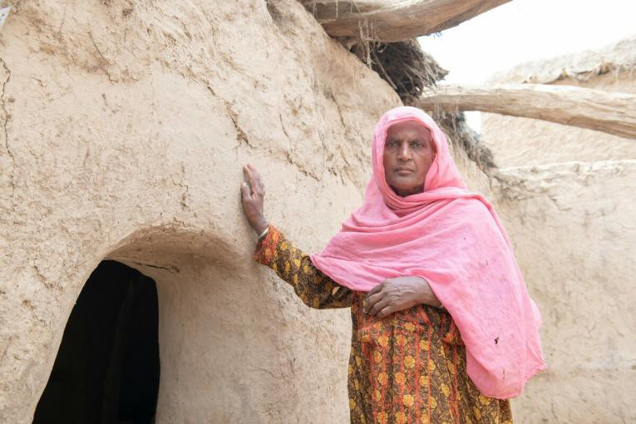
Malooka Khatoon, 70, and her husband Muhammad Bux have lived their whole lives in Pat Karira in Jhal Magsi, Balochistan. Like most families in Pat Karira, they had to flee for their lives when the flash floods engulfed their village.
“We left our houses in panic and moved to the Jhal Magsi road. I slipped on the mud during the floods and injured my leg,” said Malooka Khatoon. “This left us with terrible memories. We lost our crops and most of our livestock.”
“Before the floods, we were busy farmers and we earned a decent living,” she added. "Now we live in a tent, back where our home used to be. “Our life is very different and difficult. We
have no income and not enough food. We had to sell the last goats we had to buy food and other essential items. We are no longer able to earn a living; we have lost everything except our lives. We are depressed and worried about our losses.”
“We have no clean water as the pipes were damaged, and I have hepatitis due to the muddy water. There are no medical supplies and even if there were, we couldn’t afford them.”

Recommendations
- Cash transfers should be provided to older people when it is possible and safe to use. This is because it enables them to choose the items they need most.
- Older people should be prioritized in shelter programs. In addition, when building materials are provided, older people should be offered additional physical support, if required, to help rebuild their homes.
- Collection points should be made more comfortable for older people and people with disabilities. This includes providing seating and establishing separate queues/desks.
- Outreach services (home delivery of relief items) should be provided to those older people and people with disabilities that cannot access collection points.
- Accessible latrines should be constructed in affected areas taking into consideration the needs of older people and those with disabilities. For example, the provision of commode chairs should be included in WASH responses.
- There is an urgent need to provide lifesaving food assistance to older people and people with disabilities. However, food kits should take into consideration the dietary requirements of these groups.
- Mobile health units should be mobilized to reach and provide health services to older people and people with disabilities who cannot travel to their nearest available health provider.
- Assistive products should be added to the NFI list.
- Use different formats and communication channels to provide information to older people on the assistance available to them.
- Sex, age, and disability data should always be collected and analyzed. This is to guarantee that older people and people with disabilities needs are considered in programmatic responses.

Methodology
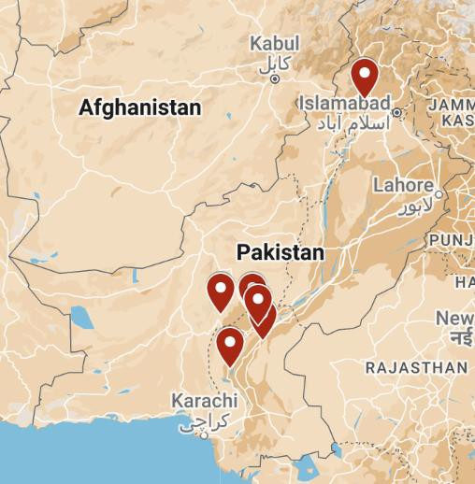
HelpAge International conducted a Rapid Needs Assessment in flood affected districts of Sindh (Jacobabad, Khairpur, Shikarpur and Dadu); Balochistan (Jhal Magsi); and Khyber Pakhtunkhwa (Nowshera) provinces, between September 21 and 26 2022.
Data were collected with the support of local partners, the Community development Foundation (CDF), Health and Nutrition Development Society (HANDS), and the Initiative for Development and Empowerment Axis (IDEA). Prior to data collection, all enumerators were trained on RNA assessment tools, including the objectives of the assessment, communicating with older people, the sampling approach and the data collection platform (Kobo).
Following the training, enumerators conducted a pilot, where any errors in question formulation were rectified.
In total 1,336 older people (55% female / 45% male) were
interviewed. Within this assessment, older people were categorized as 50+. Of those interviewed 53% reported themselves as internally displaced, 31% were returnees, 12% as host community, and 4% responded as others.
The responses were collected from older people at their current places of living and selected through purposive sampling. Enumerators shared the objectives of the data collection with the beneficiaries and secured their consent before proceeding. This approach has its limitations as it used a non-probability-based sampling approach. This sample is also weighted towards the responses of older people in Sindh. To mitigate this, we have referenced responses which significantly vary between locations. After the interviews were completed, the data was subsequently cleaned and analyzed to produce the findings of this assessment. In addition, a dashboard of the anonymized data was created. To access please email HelpAge.

Province | District | % of total
Sindh | Jacobabad | 29%
Sindh | Khairpur | 18%
Sindh | Shikarpur | 14%
Sindh | Dadu | 13%
Baluchistan | Jhal Magsi | 14%
Khyber Pakhtunkh wa | Nowshera | 14%

Demographic breakdown of older people interviewed
0.3
26% 25%
0.25
22%

0.2

0.15
0.1
9%
9%
7%
0.05
1% 1%
0
50-59
60-69
70-79
80+
Men Women

Contacts

Cindy Cox-Roman, CEO
HelpAge USA
Email: ccoxroman@helpageusa.org

Syed Moeez, Country Director, Pakistan Email: syed.moeez@helpagesa.org

