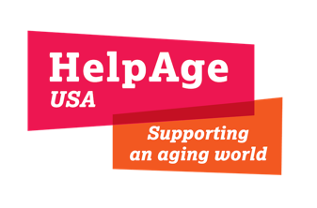
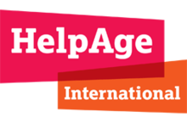

Pakistan Floods Response

Situation Report (September 19, 2022)

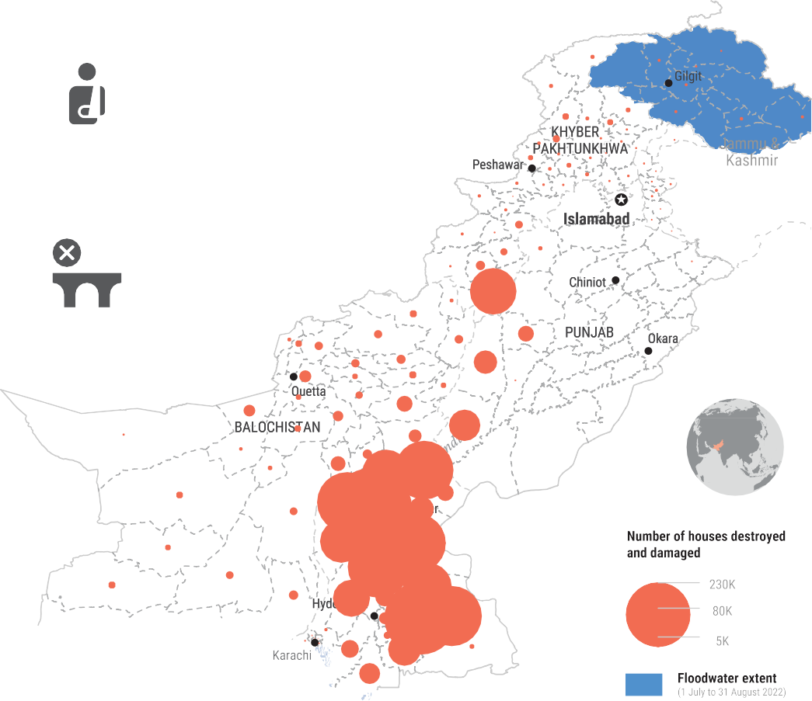
Key Figures
12,860
People Injured
374
Bridges Damaged

33 million
People Impacted

1,545
People Killed

959,819
Livestock Killed

1,958,362
Houses Damaged

81
Districts Declared ‘Calamity Hit’

12,716
KM of Roads Damaged

Sources: NDMA & UN OCHA
- - - - - - - - - - - - - - - - - - - - - - - - - - - - - - - - - - - - - - - - - - - - - - - - - - - - - - - - - - - - - - - - - - - - - - - - - - - - - - - - - - - - - - - - - - - - - - - -

The Response

Distribution of NFI Kits
Older people and people with disabilities impacted by flooding have improved access to hygiene kits and other non-food items.

Dewatering buildings
Support to local government in dewatering rain water from public buildings, including schools, hospitals, Basic Health Units, etc.

Distribution of Cash Grants
Older people, people with disabilities and ultra-poor households impacted by flooding have access to lifesaving essentials through multipurpose cash grants.

Media Campaigns

Mass-media campaigns in local languages to raise awareness among community members in the most remote areas of Pakistan.

Flood Response in Jhal Magsi District, Balochistan

Responding to the urgent needs of at-risk groups, including older people, people with disabilities, and their families in Pakistan
Donor & Lead Agency: HelpAge International
Implementing Agency: Community Development Foundation (CDF) Project Duration: August 17 - October 16, 2022 District/Province/Country: Jhal Magsi, Balochistan, Pakistan Villages to be covered: 13 villages of Jhal Magsi District

Highlights
Flooding washed out the main road to the Jhal Magsi district on August 13, 2022, cutting numerous villages off from the rest of the country. Registration of beneficiaries began on September 4, 2022. Two teams have reached 11 villages and visited 437 households to register older people and people with disabilities and distribute cash and non-food items.
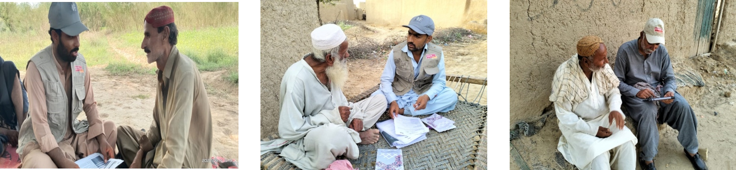

Distribution of Cash Grants
123 older people, people with disabilities, and ultra-poor households received cash grants, enabling them to access lifesaving essentials.
Total number of beneﬁciaries to be reached: 200
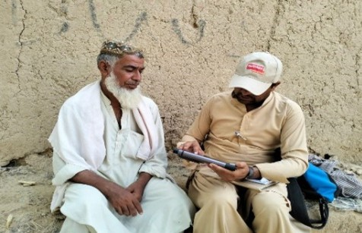
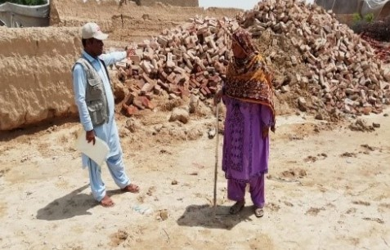
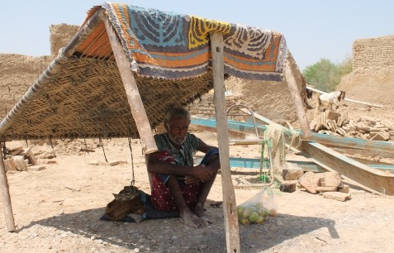

Distribution of NFI Kits
390 older people and people with disabilities received including hygiene kits and other non-food items.
Total number of beneﬁciaries to be reached: 400
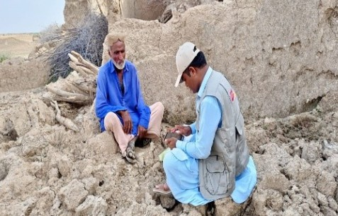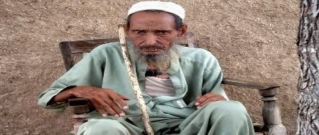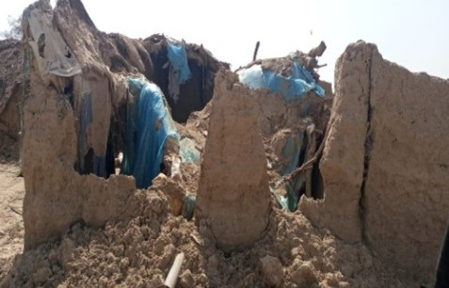

Flood Response in Khairpur, Sindh Province
Donor & Lead Agency: HelpAge International Implementing Agency: HANDS
Project Duration: 1 month Tehsil: Khairpur & Kingri
District/Province/Country: Khairpur, Sindh, Pakistan

Support to the district government regarding dewatering buildings
HelpAge International is providing support to local government in dewatering rain water from public buildings including schools, hospitals, Basic Health Units, etc. Dewatering will reduce the likelihood of outbreaks of water-borne and vector borne diseases. HelpAge International aims to address accessibility concerns and ensure public buildings are functional and accessible for all, including older people and people with disabilities.

Distribution of Non-food Items
HelpAge International distributed 250 kits with emergency shelter and non-food items to at-risk households. Each kit contains: tarpaulin sheet, bamboo poles, mosquito net, jerry can, bucket, solar lamp, water purification tablets, and rehydration packets.
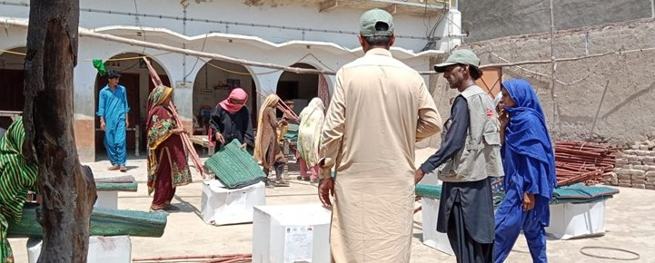
Total number of beneﬁciaries to be reached: 250

Distribution by locality:
Hadal Shah Union Council Taluka Kingri: 57 Kot Mir Muhammad Union Council Kingri: 70 Piryaloi Union Council Kingri: 63
Babarloi Union Council Taluka Khairpur: 60

Ageing and Disability Task Force
The Pakistan Aging and Disability Task Force (ADTF) has been reactivated. A meeting took place on September 15, 2022, where HelpAge International conﬁrmed to lead the group and hold the secretariat. Meetings will be conducted together with UNHCR, Pakistan Humanitarian Forum (PHF), and the National Humanitarian Network (HNH).

